浙大城市学院实验报告
课程名称 计算机网络实验
实验项目名称 实验08 NAT地址转换
学生姓名 专业班级 学号
指导老师 实验日期

一、实验目的
1. 掌握动态NAT的作用和原理；
2. 掌握NPAT的作用和原理。
二、实验设备
Cisco 2911路由器，PC机，服务器，2960交换机，双绞线若干。
三、实验步骤
1. 动态NAT实验
根据以下拓扑图和IP地址，进行NAT配置实验
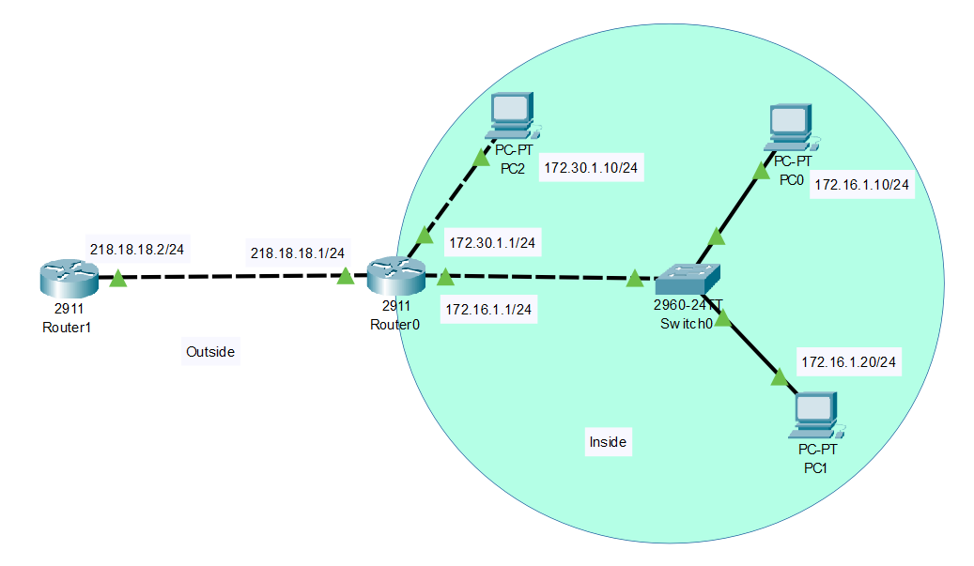

序号 | 设备 | 接口 | IP地址 | 子网掩码
1 | R0 | G0/0 | 218.18.18.1 | /24
 | R0 | G0/1 | 172.30.1.1 | /24
2 | R0 | G0/2 | 172.16.1.1 | /24
3 | R1 | G0/0 | 218.18.18.2 | /24
5 | PC0 |  | 172.16.1.10 | /24
6 | PC1 |  | 172.16.1.20 | /24
7 | PC2 |  | 172.30.1.10 | /24

1.1 拓扑图截图：
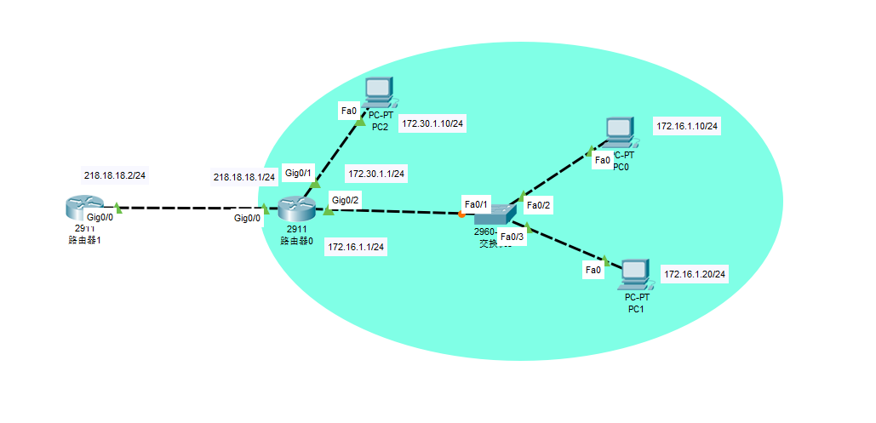

1.2 路由器R0的配置
Router>en
Router#conf t
Enter configuration commands, one per line. End with CNTL/Z.
Router(config)#interface g0/0
Router(config-if)#ip nat outside
Router(config-if)#ip address 218.18.18.1 255.255.255.0
Router(config-if)#no shutdown

Router(config-if)#
%LINK-5-CHANGED: Interface GigabitEthernet0/0, changed state to up

%LINEPROTO-5-UPDOWN: Line protocol on Interface GigabitEthernet0/0, changed state to up

Router(config-if)#interface g0/1
Router(config-if)#ip address 173.30.1.1 255.255.255.0
Router(config-if)#no shutdown

Router(config-if)#
%LINK-5-CHANGED: Interface GigabitEthernet0/1, changed state to up

%LINEPROTO-5-UPDOWN: Line protocol on Interface GigabitEthernet0/1, changed state to up

Router(config-if)#interface g0/2
Router(config-if)#ip address 173.16.1.1 255.255.255.0
Router(config-if)#no shutdown

Router(config-if)#
%LINK-5-CHANGED: Interface GigabitEthernet0/2, changed state to up

%LINEPROTO-5-UPDOWN: Line protocol on Interface GigabitEthernet0/2, changed state to up

Router(config-if)#access-list 1 permit 172.16.0.0 0.0.255.255
Router(config)#ip nat pool TEST_POOL 218.18.18.10 218.18.18.20 netmask 255.255.255.0
Router(config)#ip nat inside source list 1 pool TEST_POOL
Router(config)#

1.3路由器R1的配置
Router>en
Router#conf t
Enter configuration commands, one per line. End with CNTL/Z.
Router(config)#hostname R1
R1(config)#interface g0/0
R1(config-if)#ip address 218.18.18.2 255.255.255.0
R1(config-if)#no shutdown

R1(config-if)#
%LINK-5-CHANGED: Interface GigabitEthernet0/0, changed state to up

%LINEPROTO-5-UPDOWN: Line protocol on Interface GigabitEthernet0/0, changed state to up

R1(config-if)#

1.4 测试可达性
从PC0到路由器端口218.18.18.2
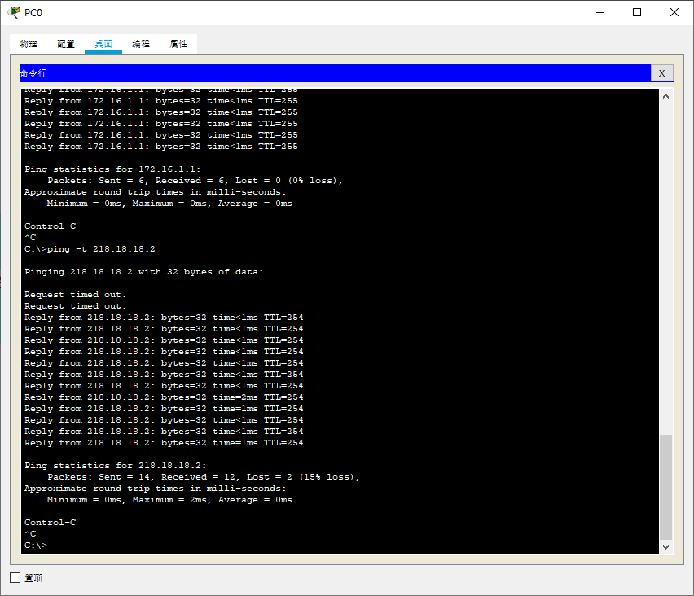
从PC1到路由器端口218.18.18.2
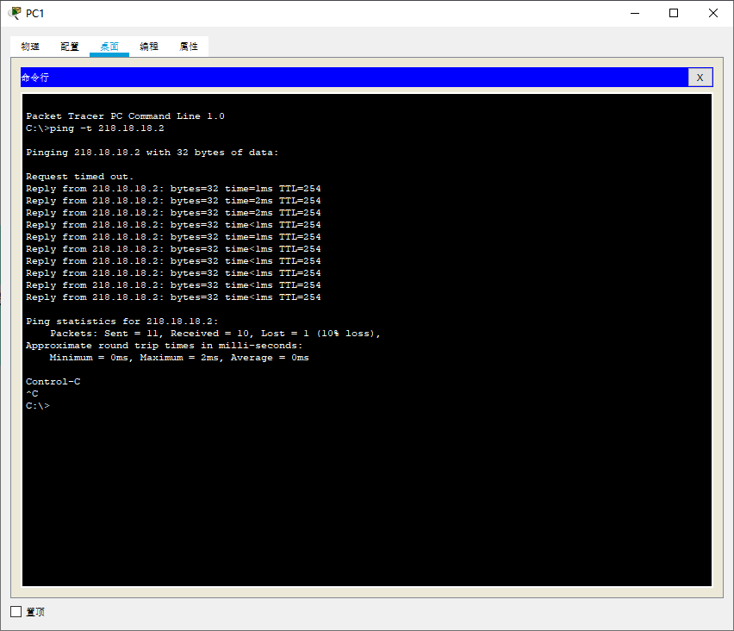
从PC2到路由器端口218.18.18.2
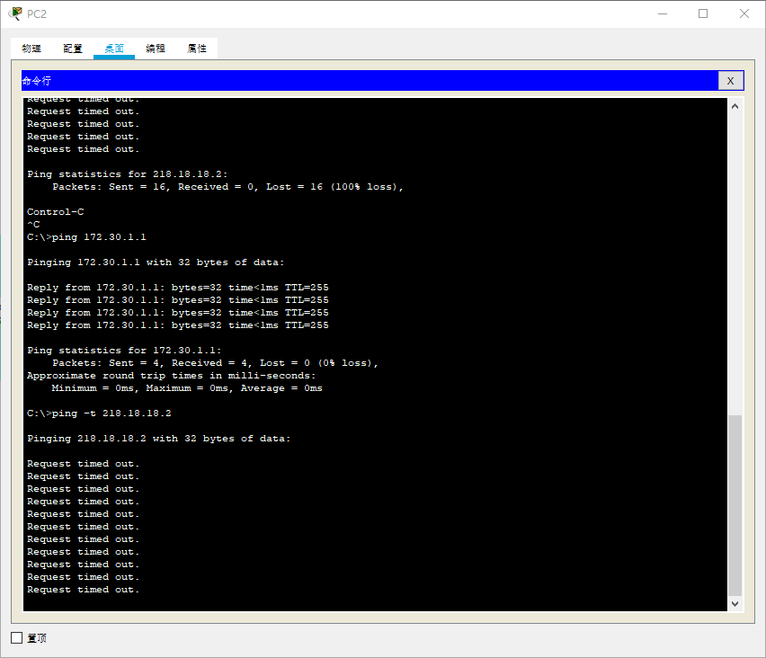

1.5 NAT转换信息截图
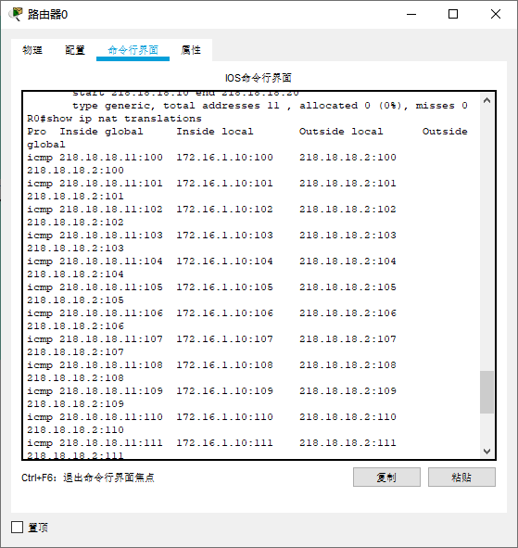

1.6 NAT统计信息截图
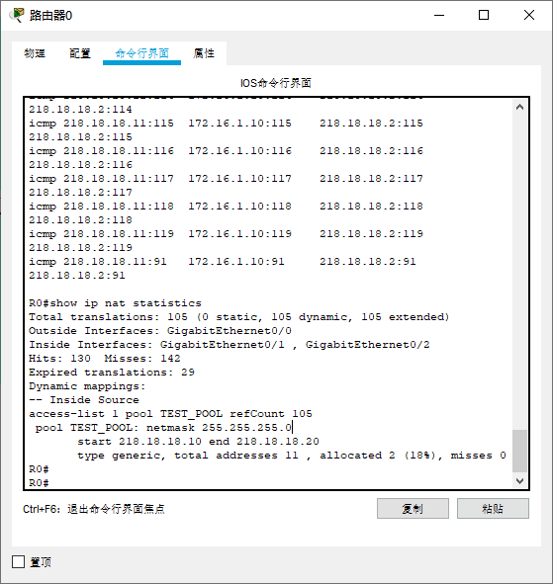

2. NPAT实验

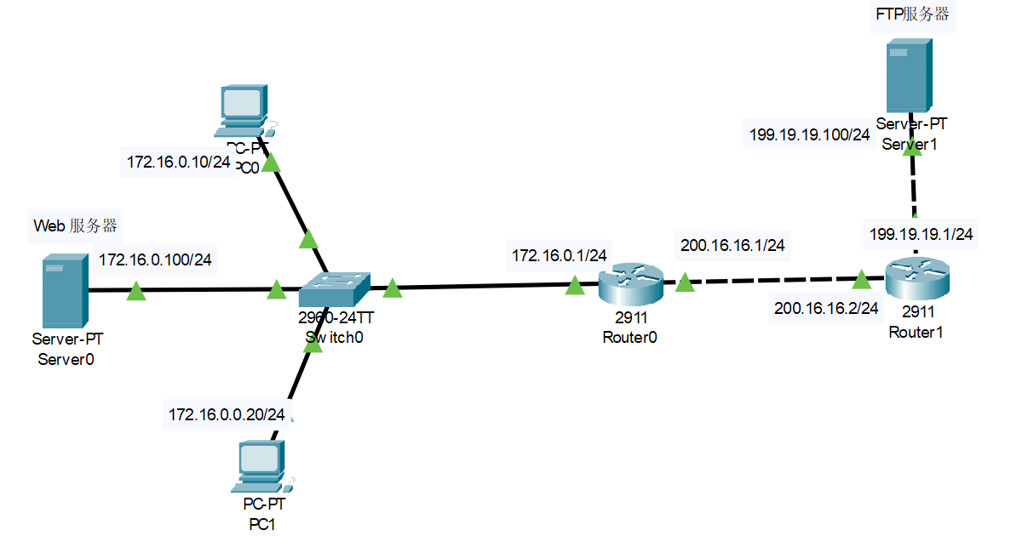
请将Route0的名字改成自己姓名的缩写
2.1 拓扑图截图如下：

2.2 填写下表
序号 | 设备 | 接口 | IP地址 | 子网掩码
1 | R0 | G0/0 | 215.15.15.1 | /24
2 | R0 | G0/1 | 10.0.0.1 | /24
3 | R1 | G0/0 | 215.15.15.2 | /24
4 | R1 | G0/1 | 210.20.20.1 | /24
5 | PC0 |  | 10.0.0.10 | /24
6 | PC1 |  | 10.0.0.20 | /24
7 | Server0 |  | 10.0.0.100 | /24
8 | Server1 |  | 210.20.20.100 | /24

2.3 路由器R0的配置
Router>en
Router#conf t
Enter configuration commands, one per line. End with CNTL/Z.
Router(config)#hostname XBH
XBH(config)#interface g0/0
XBH(config-if)#ip address 215.15.15.1 255.255.255.0
XBH(config-if)#no shutdown

XBH(config-if)#
%LINK-5-CHANGED: Interface GigabitEthernet0/0, changed state to up

XBH(config-if)#ip nat outside
XBH(config-if)#interface g0/1
XBH(config-if)#ip address 10.0.0.1 255.255.255.0
XBH(config-if)#no shutdown

XBH(config-if)#
%LINK-5-CHANGED: Interface GigabitEthernet0/1, changed state to up

%LINEPROTO-5-UPDOWN: Line protocol on Interface GigabitEthernet0/1, changed state to up

XBH(config-if)#ip nat inside
XBH(config-if)#ip route 0.0.0.0 0.0.0.0 215.15.15.2
XBH(config)#access-list 1 permit 10.0.0.0 0.0.0.255
XBH(config)#ip nat pool TEST_POOL 215.15.15.10 215.15.15.10 netmask 225.255.255.0
XBH(config)#ip nat inside source list 1 pool TEST_POOL overload
XBH(config)#ip nat inside source static tcp 10.0.0.100 80 215.15.15.100 80
XBH(config)#

2.4 路由器R1的配置

Router>en
Router#conf t
Enter configuration commands, one per line. End with CNTL/Z.
Router(config)#hostname R1
R1(config)#interface g0/1
R1(config-if)#ip address 210.20.20.1 255.255.255.0
R1(config-if)#no shutdown

R1(config-if)#
%LINK-5-CHANGED: Interface GigabitEthernet0/1, changed state to up

%LINEPROTO-5-UPDOWN: Line protocol on Interface GigabitEthernet0/1, changed state to up

R1(config-if)#interface g0/0
R1(config-if)#ip address 215.15.15.2 255.255.255.0
R1(config-if)#no shutdown

R1(config-if)#
%LINK-5-CHANGED: Interface GigabitEthernet0/0, changed state to up

%LINEPROTO-5-UPDOWN: Line protocol on Interface GigabitEthernet0/0, changed state to up

R1(config-if)#

2.5 从内网PC0访问外网的FTP服务器Server1
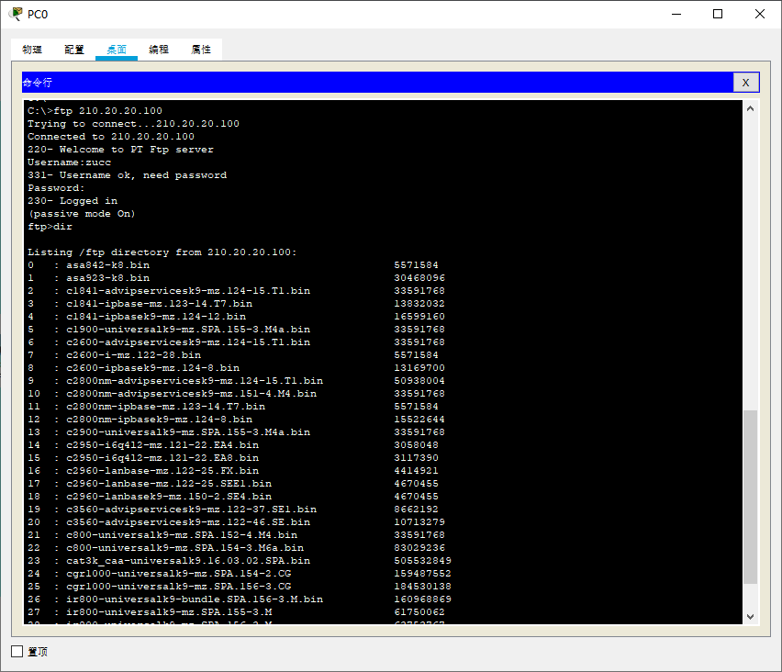

2.6 从外网的Server1，通过浏览器访问内网的Web服务器Server0,请在Web页面上显示本人的姓名和学号。
